**Merrill Lynch Case Study**

Jacob Baron, Ben Hoffman, Lucas Lantis, Reid Zuerlein

***Cash Situation (End of 2007)***

When looking at Merrill Lynch from a cash perspective, they don’t appear to be a firm in distress. However, by examining the entire picture, holes begin to appear in their financial stability. While Merrill Lynch’s cash and equivalents balance increased from 2005 to 2007, this can be explained by their massive sell offs in investment activities. What appears as a growing base of safe cash was hiding hemorrhaging investment losses where traders were urgently selling any and all bad real estate assets. This will be examined further in the ***Investment Activities*** section.

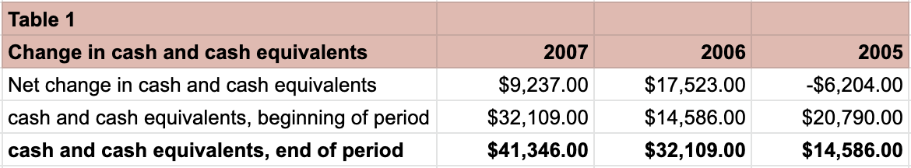

***Operating Activities (End of 2007)***

From 2005 to 2007, the amount of cash used in operating activities consistently increased. In 2005 and 2006, although the amount of cash used for operating activities grew, net income grew by over $2 billion and net income was positive. By the end of 2007, Merrill Lynch used -$72,362 (in millions) on operating activities and unlike 2005 and 2006, net income was almost -$8 billion. In just one year, Merrill Lynch went from making $7.5 billion, to losing $7.8 billion. Furthermore, in 2006, Merrill Lynch was grossing over $11 billion in funds from operations. By the end of 2007, that number plummeted to -$9.8 billion.

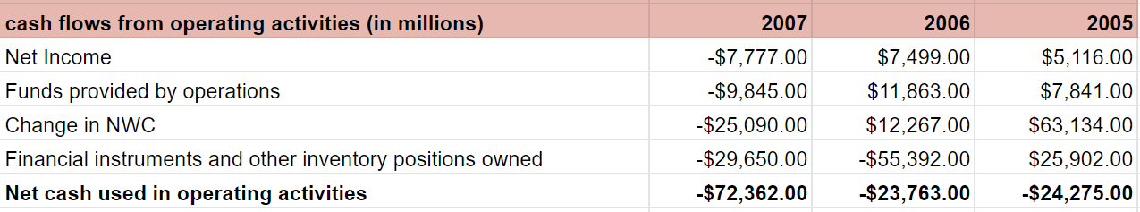

***Investment Activities (End of 2007)***

Merrill Lynch was taking substantial losses from investment activities from 2005 to 2007. In 2006, net cash from investing activities was a loss greater than $11 billion. There was a small improvement in 2007, where they recognized a $7 billion loss. However, free cash flows from 2005 to 2007 were increasingly negative. Free cash flow in 2005 was negative $25 billion. By 2007, this number had tripled and Merrill Lynch was losing $75 billion in free cash flows that year.



***Financing Activities (End of 2007)***

Financing activities are another area of concern when evaluating Merrill Lynch at the end of 2007. Long-term debt had been increasing year over year from 2005 to 2007. From 2006 to 2007 alone, long term debt increased from $87,814 to $165,107 (in millions). With these increased long-term borrowings, came increased costs on long-term debt payments. At the end of 2007, Merrill Lynch was paying out -$93 billion in principle payments of long-term borrowings. From 2006 to 2007, Merrill Lynch had a 121% increase in payments of long-term borrowings.

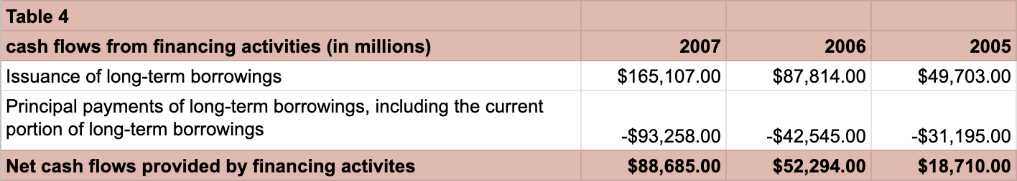

***Recommendation***

Based on the quantitative analysis of cash flows from Merrill Lynch from 2005 to 2007, we would recommend a potential investor to hold off on making a stock purchase of the company in 2008. There were clear warning signs that Merrill Lynch was heading for trouble. Long-term debt was growing tremendously, there was a steep drop in net income, and the organization was rapidly selling off investments and increasing operating expenses.

Grade 40/40